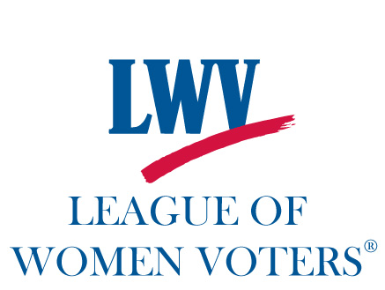League of Women Voters of New Hampshire
LWVNH, Peterborough Plus
LWVpboroplus@gmail.com
May 1, 2019
Dear Candidate,
With less than a week to go before our “Meet the Candidates” Candidate Forum in co-sponsorship with the Monadnock Ledger-Transcript, we would like to let you know how the evening’s event will be structured.
Date: May 6, 2019
Time: 7-9 pm. CANDIDATES PLEASE ARRIVE: 6:40 pm.
Place: Bass Hall at The Monadnock Center for History and Culture, 19 Grove Street
The League of Women Voters is a non-partisan political organization dedicated to informing the voting public. Toward that end, one of our voter service activities is hosting candidate forums in order to allow the public to meet the candidates and hear their views on a variety of topics. The PeterboroughPlus unit hosted last year’s Peterborough Candidate Forum (also moderated by Liz Tentarelli, President of LWVNH) as well as Candidate Forums for House of Representatives and State Senate races. We have a proven track record for fair, informative, non-partisan Candidate Forums.
PLEASE READ CAREFULLY THE FOLLOWING INFORMATION ABOUT EVENT PROTOCOL
• There will be a table for Candidate Literature in the front entryway to Bass Hall. You may not place candidate literature anywhere other than this table. No candidate signs allowed.
• No filming or videotaping allowed. The Ledger-Transcript will cover the event and they are permitted to take photographs.
• There will be a copy of the Sample Ballot on each seat, and we will have nametags for you.
• Liz Tentarelli as moderator will welcome everybody and explain the rules.
• Those of your running for Budget Committee, Recreation Committee and Zoning Board (10 candidates) will be seated in the front row. Liz will invite you to stand and introduce yourselves in no more than TWO SENTENCES. We have used this format before and it works! Then you will sit. At the end of the Forum, there will be a period for questions, and you might get some questions at that point, so please do not leave.
• At the front of the room, facing out, there will be three tables, with nametags in place, for the candidates for Planning Board (4 candidates) and Select Board (2 candidates). There will be nameplates on the tables, but Liz, as moderator, will draw your names at random to determine the seating and speaking order. Planning Board will go first (time allotted: 20-25 minutes), followed by Select Board (time allotted: 20-25 minutes).
--Opening Statements: 1 minute max. We suggest you briefly describe your qualifications for the Board, and your ideas and plans for the coming term, if elected. We want the bulk of the time in your segment to be devoted to Q & A.
--A question and answer period will follow for EACH board, separately (Planning Board first, Select Board second). Liz Tentarelli as moderator will use questions that have been submitted to the newspaper, and questions written by audience members at the Candidate Forum. Please note that written questions will stay in LWV possession after the event. You will be limited to TWO minutes per answer, so please plan accordingly. The League has timers who will alert you when you have 30 seconds left (yellow paddle) and when your time is up (red paddle).
When both the Planning Board and the Select Board have had their turns, Liz will open the Forum to questions that could be for any of the candidates for office. The same rules apply: Written questions only, no impromptu oral questions from the floor. TWO minute time limit per answer. That said, Liz is our skilled and experienced moderator, and she may choose to add what we call a “Lightning Round” question that can be something fun and unifying, like, “What is your favorite place in Peterborough to go for a snack?” or a local issue that wasn’t highlighted in the Forum: “How do you like the new parking lot and pedestrian bridge to Depot Square?” (One sentence why…)

We will have refreshments after the Q&A so that people can speak directly to any of our candidates running for office.

- Thank you for running for elected office here in “Our Town” of Peterborough. Please don’t hesitate to each out to me if you have questions about the Candidate Forum next Monday. And… good luck!

Respectfully,
Kate Coon, Chair: LWVNH, PeterboroughPlus

