

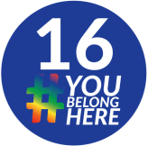

Creating a Sense of
Belonging
Through Affinity Spaces

What are affinity spaces?
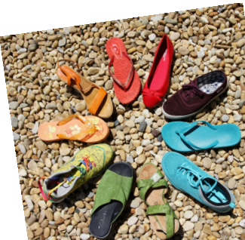

They are identity-based groups that allow students who share an identity to connect, talk openly about experiences related to that identity, and brainstorm positive action steps for promoting inclusion and equity in the CMS community.

These spaces are designed for historically marginalized groups (e.g. PoC - People of Color, LGBTQIA+ identities, etc.) and provide unique opportunities for safe, open sharing.

Who can join an affinity space?
Anyone who identifies with that particular identity is welcome to join the group, and friends/allies may also be invited to participate.
Affinity space members should feel like they can safely express themselves without having to worry about others who may not understand their experiences because they don’t share that particular identity.
For people who often experience prejudice and discrimination, these affinity spaces serve as powerful sources of energy and support.
What activities happen in an affinity space? In an affinity space, you might:
Make connections with people who share similar experiences
Discuss ideas about creating a sense of belonging for all students
Design events and activities that celebrate and educate on topics that come up in the group
And MUCH MORE...
Don’t affinity spaces create more separation and exclusion?
Actually, just the opposite -- these groups enhance our commitment to inclusivity and creating a sense of belonging for everyone.
Affinity groups are only“exclusive” in order to create safe spaces for students who may experience discomfort in the larger community because they are in Write Your Big Topic or Idea
the numerical minority. During affinity group meetings, students can share freely about their experiences, which may help them feel more visible and Elaborate on what you want to discuss.
valued as part of the wider community.
Still have questions?
Find out more about affinity spaces by talking to:
Kate Beach Kelly O'Brien
6th Grade LGBTQIA+ Group
Clyde Perezcastaneda -
Students of Color & Allies
Lisa Sloan
Brie Taylor
Becky Saunders -
7th Grade LGBTQIA+ Group 8th Grade LGBTQIA+ Group

